Student’s name | …………………………………………………….…… | Grade | 6
Subject | Computer | Week No. | 4
Lesson Title | Platformer Movement | Unit
Worksheet No. ( 4 )
Question A: write the correct name of each part.

Types of video games (P129)
Racing | Puzzle | Role playing
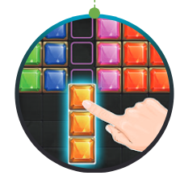


Good Luck

